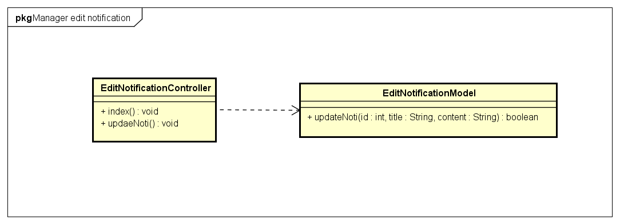

|  |  |
| --- | --- |
| **EditNotificationController** | |
| **Physical address** | admin/application/controllers |
| **Base class** |  |
| **Attributes** | |
| N/A | |
| **Operations** | |
| index() | |
| **Return Type** | void |
| **Parameters** | N/A |
| updateNoti() | |
| **Return Type** | void |
| **Parameters** | N/A |

|  |  |  |  |
| --- | --- | --- | --- |
| **EditNotificationModel** | | | |
| **Physical address** | admin/application/models | | |
| **Base class** |  | | |
| **Attributes** | | | |
| N/A | | | |
| **Operations** | | | |
| updateNoti() | | | |
| **Return type** | boolean | | |
| **Parameters** | **Name** | **Type** | **Description** |
|  | Id | Int | Notification id |
|  | title | String | Notification title |
|  | content | String | Notification content |